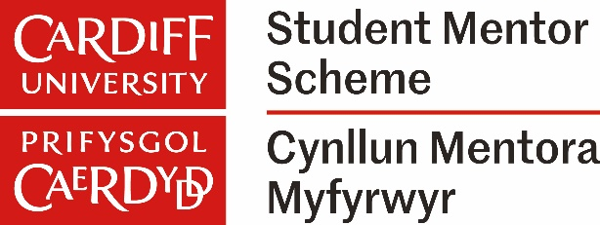
This certificate is awarded to
Differing y dystysgrif hon i
Student Mentor Scheme

Cynllun Mentora Myfyrwyr
in recognition of being a senior student mentor with commitment to supporting a group of student mentors, as well as working with staff during 2024/25 to develop the scheme.
i gydnabod ei bod yn uwch fentor myfyrwyr gydag ymrwymiad i gefnogi grŵp o
fentoriaid myfyrwyr, yn ogystal â gweithio gyda staff yn ystod 2024/25 i ddatblygu'r cynllun.
Chloi Neophytou

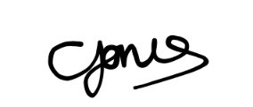
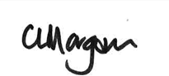
Claire Morgan
Rhag Is-Ganghellor Addysg a Myfyrwyr
Pro Vice-Chancellor for Education and Students
Carly Jones
Rheolwr Sgiliau Astudio Academaidd a Mentora
Academic Skills and Mentoring Manager

